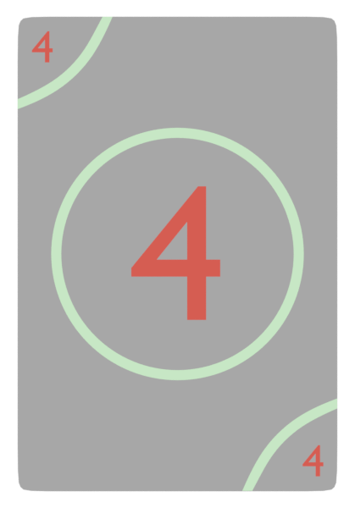

**AS A USER**

**I WANT TO** enter to instructor page

**So that** I know his/her career

**AS A USER**

**I WANT TO** enter my account

**So that** watch the courses

**AS A USER**

**I WANT TO** make account

**So that** watch the courses

**AS A USER**

**I WANT TO** enter data

**So that** contact with support

**AS A USER**

**I WANT TO** enter to course

**So that** leave a comment

**AS A USER**

**I WANT TO** enter to courses

**So that** watch course

**AS A USER**

**I WANT TO** search

**So that** search for courses

**AS A USER**

**I WANT TO** enter to home  
**so that** I know what

Website offers

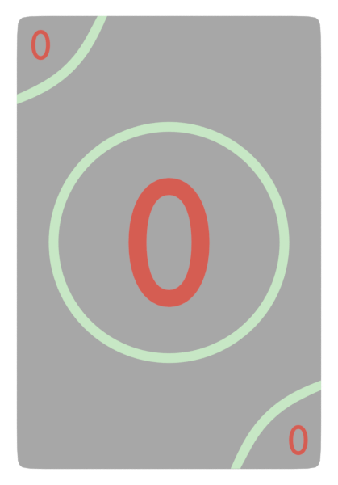

**AS A USER**

**I WANT TO** logout my e-mail

**So that** I watched the course

**AS A USER**

**I WANT TO** enter to page

**So that** buy courses



**AS A USER**

**I WANT TO** get some information

**So that** know the owner of product

|  |  |
| --- | --- |
| General Project Information | |
| Project Name | FC; Learining System |
| sprint time | 2week |
| scrum master | Yahia Mohamed |
| Stakeholders | anyone want E- learning |
| Expected Start Date | 1-Mar |
| Expected Completion Date | 29-April |
| product owner | E-learing company |
| Budget | 15000$ |